TITLE OF THE PROJECT

MINI PROJECT REPORT

Submitted by

NAME
SEMESTER

BACHLER OF TECHNOLOGY IN
INTERNET OF THINGS

DEPARTMENT OF COMPUTER SCIENCE AND ENGINEERING
SHIV NADAR UNIVERSITY CHENNAI

APRIL 2025



ABSTRACT

TABLE OF CONTENTS

CHAPTER NO. TITLE PAGE NO. ABSTRACT
- INTRODUCTION
  - Overview
  - Problem Statement
  - Objectives
  - Motivation
- BACKGROUND
  - Stock Price Prediction Techniques
  - Overview of Sequence-Based Architectures
- METHODOLOGY
  - Data Collection
    - Stock Price Data
  - Data Preprocessing
  - Model Architecture and Design
    - BiLSTM Model
- RESULTS AND ANALYSIS
  - Model Performance Comparisons
- CONCLUSION AND FUTURE WORK
  - Interpretation of Results
  - Limitations and Considerations
REFERENCES

CHAPTER 1 INTRODUCTION

Overview
Stock price prediction is a central focus in financial forecasting, offering valuable insights for investors, traders, and analysts. The ability to anticipate stock price movements accurately can significantly impact investment strategies and financial decision-making. However, due to the inherent volatility and complexity of financial markets, accurately predicting stock prices remains a challenging task. Traditional forecasting methods, such as moving averages and autoregressive models, are often limited by their linear approach, making it difficult for them to capture the nonlinear and sequential patterns that characterize stock market data.

Problem Statement
In the realm of financial forecasting, conventional models often struggle with
two primary challenges: capturing the complex sequential nature of stock price data and accounting for external factors, such as investor sentiment, that can cause abrupt price fluctuations. Traditional statistical models, while effective for certain applications, are often limited by their inability to process nonlinear and sequential patterns effectively. This limitation becomes even more pronounced in stock markets, where prices are influenced by a combination of technical factors (e.g., historical price trends) and fundamental factors (e.g., investor sentiment, macroeconomic news).

Objectives
The primary objective of this research is to improve the accuracy and reliability of stock price predictions by leveraging advanced sequence-based architectures and sentiment analysis. Specific objectives include:

Evaluate Sequence-Based Architectures: To systematically assess the predictive performance of various sequence-based architectures, including RNN, LSTM, BiLSTM, and a hybrid BiLSTM-GRU model, for stock price forecasting.

Motivation
The motivation behind this research stems from the potential benefits of accurate stock price prediction for various stakeholders in the financial sector, including retail investors, institutional traders, and financial analysts. Stock markets are influenced by an intricate interplay of technical factors, such as historical trends, and fundamental factors, including investor sentiment, economic announcements, and geopolitical events. While traditional forecasting methods tend to focus predominantly on technical analysis, they often overlook
the psychological and emotional drivers that can impact market movements, especially during periods of economic uncertainty or market volatility.

CHAPTER 2 BACKGROUND

Stock Price Prediction Techniques
Stock price prediction is a critical focus in finance, aiming to provide insights into future price movements to support investment decisions, risk management, and trading strategies. Traditional forecasting approaches, including technical analysis and statistical models, use historical price patterns, trading volumes, and technical indicators to extrapolate future price trends. Common statistical methods, such as Moving Average (MA), Autoregressive Integrated Moving Average (ARIMA), and Exponential Smoothing, are effective for linear and stationary data but are often limited in handling the nonlinear, volatile nature of financial markets.

Overview of Sequence-Based Architectures
Sequence-based architectures have become integral to fields that require analysis of time-dependent data, such as finance, language processing, and
signal processing. They are designed to process sequences by retaining information from previous steps, allowing them to learn patterns over time. In the context of stock price prediction, these architectures enable the model to consider historical price movements and make predictions based on observed trends. This section explores the key architectures employed in this study, highlighting each model's strengths and limitations.

Recurrent Neural Networks (RNN)
Recurrent Neural Networks (RNNs) are foundational models for sequence data analysis. Unlike feedforward neural networks, RNNs include recurrent connections, which allow them to "remember" information from previous time steps. This memory mechanism is especially useful for time-series data, where understanding past values can improve the accuracy of future predictions. However, RNNs often face challenges like the vanishing gradient problem, where gradient values shrink during backpropagation, causing the model to forget long-term dependencies. This limitation reduces their effectiveness for predicting stock prices over extended periods. Despite this, RNNs remain essential building blocks for more advanced architectures and provide valuable insights into short-term market fluctuations.

Long Short-Term Memory (LSTM)
Long Short-Term Memory (LSTM) networks were developed to overcome the vanishing gradient problem encountered in RNNs. LSTMs introduce a complex structure with memory cells and gating mechanisms—namely, input, output, and forget gates—that regulate the flow of information through the network. This gated structure enables LSTMs to selectively remember or forget information, allowing them to retain important information over long time sequences [1]. This ability to capture long-term dependencies makes LSTMs particularly suitable for stock price prediction, where trends and patterns may unfold over days, weeks, or even months. By balancing short-term and long-

term memory, LSTMs offer a robust solution for financial forecasting, making them a popular choice in time-series applications.

Bidirectional LSTM (BiLSTM)
Bidirectional LSTMs (BiLSTM) are an extension of LSTM networks that enhance their capability by processing data in both forward and backward directions. In traditional LSTMs, the model only considers past data, which can limit its ability to capture the full context of a sequence [2]. BiLSTMs address this limitation by introducing two layers—one that reads the sequence from start to end, and another that reads from end to start. This bidirectional structure enables the model to leverage both past and future contexts, providing a richer understanding of the sequence. For stock price prediction, BiLSTMs can analyze dependencies in both directions, improving the model’s ability to recognize intricate patterns and relationships in price movements. This project includes BiLSTMs to evaluate whether the bidirectional approach yields greater predictive accuracy in the financial domain.

Hybrid Models (BiLSTM-GRU)
Hybrid models combine multiple architectures to harness the advantages of each, creating more robust and versatile solutions. The BiLSTM-GRU model used in this project merges the bidirectional processing of BiLSTMs with the efficiency of Gated Recurrent Units (GRU). GRUs simplify the LSTM structure by combining the forget and input gates into a single update gate, reducing computational complexity while retaining effective memory capabilities. By combining BiLSTM’s bidirectional context with GRU’s computational efficiency, the BiLSTM-GRU hybrid model aims to capture intricate dependencies in stock data with minimal computational overhead. This model is designed to provide a balanced approach to prediction, leveraging the strengths of both architectures to achieve improved accuracy and efficiency in stock price forecasting.

Fundamentals of Sentiment Analysis
Sentiment analysis is the process of analyzing text to determine the emotional tone—positive, negative, or neutral—associated with it. In the financial sector, sentiment analysis has become a valuable tool for capturing investor sentiment, which can significantly influence stock prices. Market sentiment reflects public opinion on various economic indicators, company performance, and geopolitical events. By understanding these sentiments, models can become more responsive to the factors driving stock prices, particularly in the short term. Sentiment analysis has traditionally been a part of fundamental analysis, adding a qualitative dimension to technical indicators and improving the overall predictive capability of stock price models.

Role of Sentiment in Stock Price Prediction
Sentiment plays a substantial role in stock price movements, often serving as a leading indicator for short-term price fluctuations. Positive sentiment surrounding a company can increase investor confidence, driving up demand and thus, prices.

Sentiment Analysis Models (e.g., FinBERT)
In recent years, specialized language models have emerged to improve the accuracy of sentiment analysis, especially in the financial sector. FinBERT, a variant of the BERT (Bidirectional Encoder Representations from Transformers) model, has been fine-tuned specifically for financial sentiment analysis. Unlike traditional sentiment analysis models, FinBERT can interpret
complex financial terminology and context, making it more suitable for assessing market sentiment from news articles, financial reports, and other financial texts.

CHAPTER 3 METHODOLOGY

This chapter presents a comprehensive overview of the methodologies used to design, implement, and evaluate models for stock price prediction integrated with sentiment analysis. The process is illustrated in Fig 3.1, which provides a structured approach from data collection to model training and performance evaluation. Each methodological step is outlined in detail below, offering a clear understanding of the techniques and processes that enable effective prediction of stock price trends.
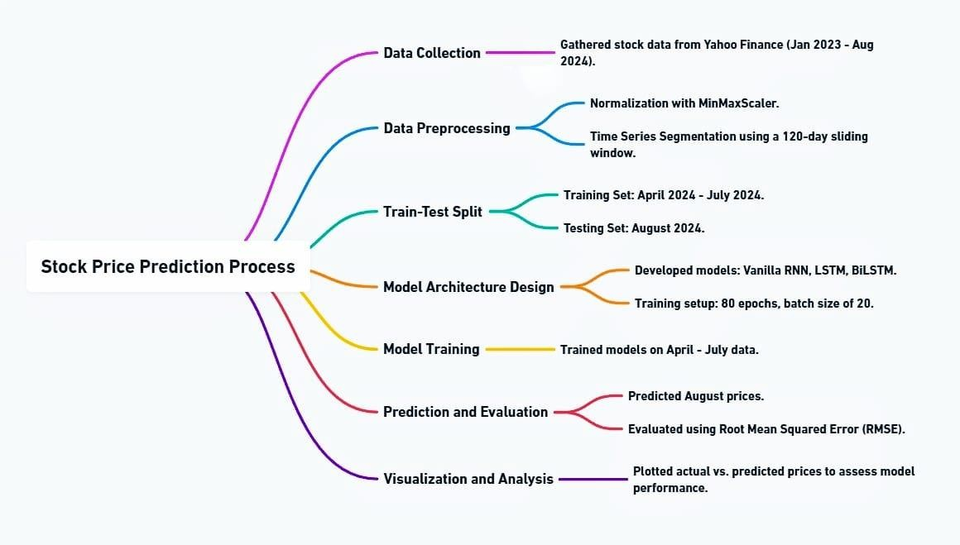
Fig 3.1 : Stock Price Prediction Process

Data Collection
Data collection is the foundational phase of this study, as it involves gathering and preparing the essential inputs required for model training and prediction. For this project, two primary data sources are considered to capture both the technical and fundamental aspects of stock price movements: historical stock

price data and sentiment data derived from financial news articles. This dual approach enables the model to capture complex market dynamics, combining traditional quantitative indicators with sentiment-based qualitative factors.

Stock Price Data
Stock price data serves as the primary quantitative input, offering historical insights into price fluctuations over time. Key metrics include daily open, close, high, and low prices, as well as trading volume and adjusted closing prices. These indicators are crucial for capturing patterns and trends that define typical stock behavior.

News Sentiment Data
News sentiment data provides critical insights into market reactions to events that influence stock prices. This data is collected from financial news articles using Yahoo Finance's RSS feeds, specifically tailored to stock-specific headlines. By analyzing these articles, sentiment scores—categorized as positive, negative, or neutral—are generated, providing valuable context for market behavior.

Data Preprocessing
Data preprocessing is a crucial step that prepares raw data for analysis by transforming it into a format suitable for modelling. Preprocessing is essential for reducing noise, handling inconsistencies, and optimizing data quality, which significantly affects model accuracy and robustness.

Model Architecture and Design
This section elaborates on the various sequence-based model architectures employed in the stock price prediction task. These architectures are chosen based on their capacity to capture temporal dependencies and patterns within the data, which are crucial for effective time-series forecasting.

RNN Model
Recurrent Neural Networks (RNNs) are a fundamental class of neural networks designed for sequential data processing. RNNs maintain an internal state that helps them recognize patterns over time, making them suitable for time-series prediction. In this project, RNNs serve as a baseline model, providing insights into how sequential dependencies in stock price data can be leveraged for forecasting. However, RNNs have limitations, particularly the vanishing gradient problem, which restricts their ability to capture long-term dependencies [5]. Despite this drawback, RNNs are used as an initial benchmark to explore the feasibility of sequence-based models in stock prediction.

CHAPTER 4 RESULTS AND ANALYSIS

Model Performance Comparisons
This section presents a comparison of model performances across different sequence-based architectures applied to stock price prediction: Simple RNN, LSTM, BiLSTM, and the BiLSTM-GRU hybrid model. The evaluation was conducted using key metrics — Root Mean Square Error (RMSE), Mean Absolute Error (MAE), and Mean Percentage Error (MPE) — to assess each model's accuracy in capturing stock price trends, handling long-term dependencies, and managing computational efficiency.

Effectiveness of Hybrid Model
The BiLSTM-GRU hybrid model represents a key innovation in this study, leveraging the combined strengths of BiLSTM and GRU architectures to overcome the limitations observed in traditional models. BiLSTM's bidirectional nature allows the model to understand both past and future contexts within the data, enhancing its capability to capture complex temporal dependencies. The GRU component reduces computational overhead by using simplified gates, which enables efficient processing without sacrificing performance. This balance of complexity and computational efficiency makes the hybrid model particularly effective for stock price prediction, where both data fidelity and model speed are crucial.

Impact of Sentiment Analysis on Prediction Accuracy
Incorporating sentiment analysis added a valuable layer of context to the prediction models, addressing gaps that traditional numerical data could not fill. Stock prices are often influenced by investor sentiment, derived from sources like news articles and social media. In this project, sentiment data was obtained from news sources and analyzed using FinBERT, a language model tailored for financial sentiment analysis, categorizing sentiment as positive, neutral, or negative. This sentiment information was integrated as an additional feature in the predictive models.

Visualization of Results
Visualizing the results provides an intuitive comparison of each model's performance in predicting stock prices. Graphs were generated for Simple RNN, LSTM, BiLSTM, and the BiLSTM-GRU hybrid model to showcase their predicted prices alongside actual stock prices over a specified testing period. These visualizations allow for an easy comparison of each model's alignment with real price movements, particularly in volatile periods.

CHAPTER 5 CONCLUSION AND FUTURE WORK

Interpretation of Results
This study investigated sequence-based models, specifically BiLSTM and LSTM networks, for stock price prediction while integrating sentiment analysis through a Stock Sentiment Analyzer. The results demonstrate that sequence- based models, particularly BiLSTM, exhibit superior performance compared to traditional models in capturing stock price trends. The hybrid approach, which combines sentiment analysis with price prediction, offered a more accurate and robust forecast by incorporating market sentiment into predictive analytics.

REFERENCES

- Kanaparthi, V. (2024). "Robustness evaluation of LSTM-based deep learning models for Bitcoin price prediction in the presence of random disturbances," International Journal of Innovative Science and Modern Engineering (IJISME), Vol. 12, Issue 2, pp. 14–18.

- Avci, Cigdem, Bedir Tekinerdogan, and Cagatay Catal. "Analyzing the performance of long short-term memory architectures for malware detection models," Concurrency and Computation: Practice and Experience, Vol. 35, Issue 6 (2023), pp. 1–1.

- Kanaparthi, Vijaya. "Robustness Evaluation of LSTM-based Deep Learning Models for Bitcoin Price Prediction in the Presence of Random Disturbances," Sciences, Vol. 2054 (2024), pp. 3101.

- Billah, Md Masum, et al. "Stock price prediction: comparison of different moving average techniques using deep learning model," Neural Computing and Applications, Vol. 36, No. 11 (2024), pp. 5861–5871.

- Beltozar-Clemente, Saul, et al. "Predicting customer abandonment in recurrent neural networks using short-term memory," Journal of Open Innovation: Technology, Market, and Complexity, Vol. 10, No. 1 (2024), Article 100237.

- Selmy, Hend A., Hoda K. Mohamed, and Walaa Medhat. "A predictive analytics framework for sensor data using time series and deep learning techniques," Neural Computing and Applications, Vol. 36, No. 11 (2024), pp. 6119–6132.

